SOCIAL MEDIA ANALYTICS
2. Social Network Structure, Measures & Visualization
Basics of Social Network Structure - Nodes, Edges & Tie Describing the Networks Measures - Degree Distribution, Density, Connectivity, Centralization, Tie Strength & Trust Network Visualization - Graph Layout, Visualizing Network features, Scale Issues. Social Media Network Analytics - Common Network Terms, Common Social Media Network Types, Types of Networks, Common Network Terminologies, Network Analytics Tools.
PAST QUESTIONS:
- Explain Tie-Strength in social media network structure. (M24)
- Social media network structure is given below. Answer the given questions. (M24)
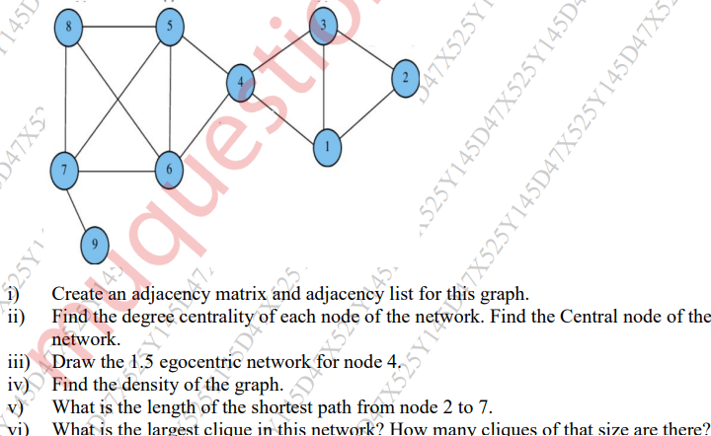
- Explain Tie strength and trust. What significance of weak ties in a social network? (M25)
- (M25)
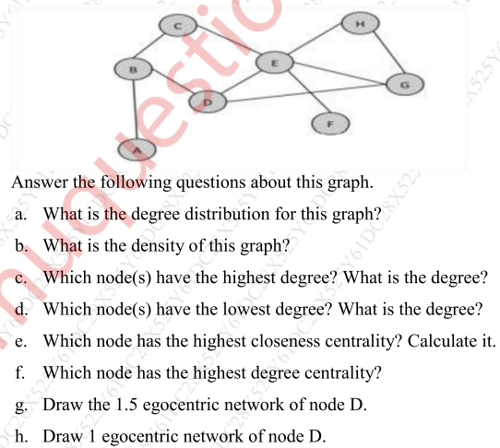

NOTES:

*Tie Strength :-
*Trust :-

